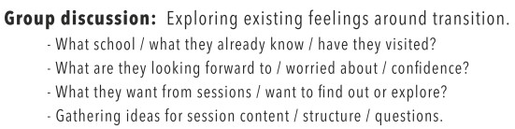

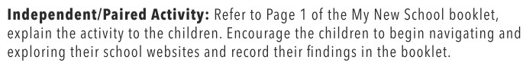

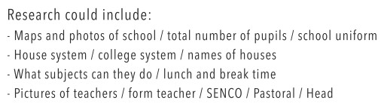

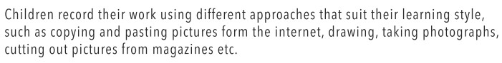

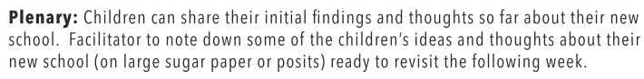

Week 1
An adapted session plan is:
Introduction Task

- On the contents page of your booklet, score how much you know about the high school you are going to?
Use a scale of 1 to 10 where 10 is everything I need to know and 1 is really nothing.
1 10

- On the contents page of your booklet, score how confident are you feeling about going to high school?
Use a scale of 1 to 10, where 10 is very positive and 1 is very worried.
1 10

3) Go to page 1 of your booklet and find out at least 8 facts about your new
school including:
- The number of children at your school
- The number of children in your form
- Whether your school has a uniform
- Your new subjects

6) Optional Task: On a separate piece of paper find and paste at least 4 pictures of the school from their website – aerial, pictures of the buildings, logo and facilities.
Adapted Session plans by Debbie Davis (SENCo, Colman Junior School)

